TP Final

Ricardo Vallejo

Yulia Kalugina

---3. SQL

----3.1. Charger le jeu de donnees « data_person_profiles.txt ».---

CREATE TABLE public.data_person_profiles

(

age integer,

work_class varchar(50),

salary integer,

education varchar(50),

education_num integer,

marital_status varchar(50),

occupation varchar(50),

relationship varchar(50),

race varchar(50),

gender varchar(50),

capital_gain integer,

capital_loss integer,

hours_per_week integer,

country varchar(50),

target varchar(50)

)

TABLESPACE pg_default;

ALTER TABLE public.data_person_profiles

OWNER to postgres;

---3.2. Comparer le salaire d'un employee avec le salaire moyen des autres employees---

SELECT SALARY,

(SELECT AVG(SALARY) FROM DATA_PERSON_PROFILES) AVG_SALARY

FROM DATA_PERSON_PROFILES;

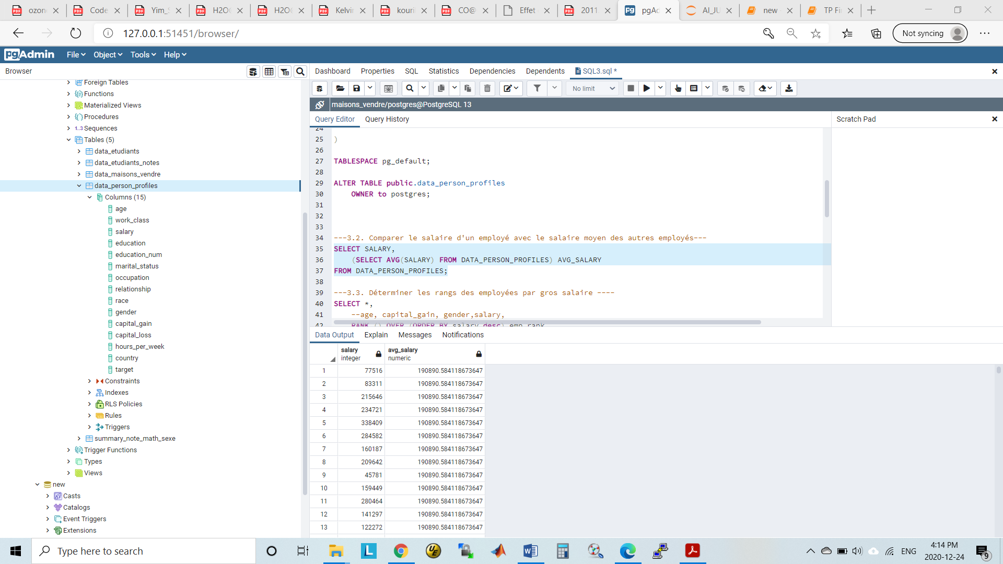

---3.3. Determiner les rangs des employees par gros salaire ----

SELECT *,

RANK () OVER (ORDER BY salary desc) emp_rank

FROM

data_person_profiles;

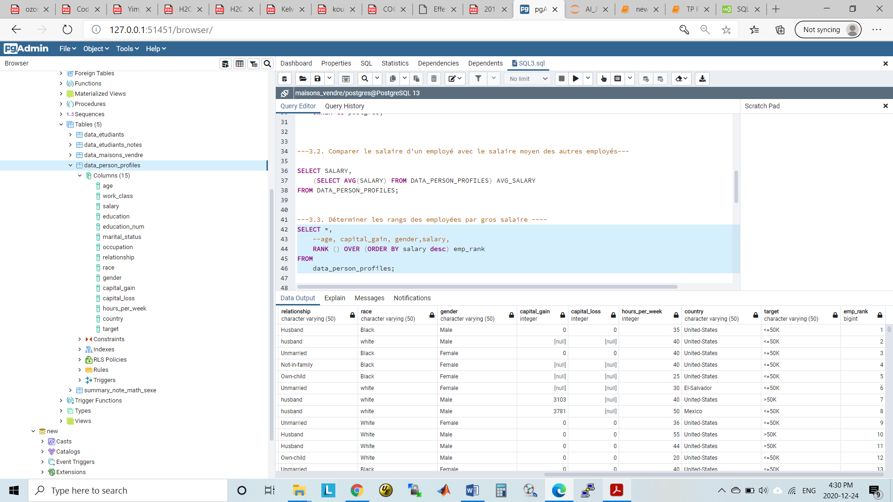

---3.4. Determine les 10 premiers rangs des employees par age, capital-gain et sexe ---

--by age

SELECT

age, capital_gain, gender,salary, RANK () OVER (

ORDER BY age

) emp_age

FROM

data_person_profiles limit 10;

-- data_person_profiles order by salary limit 10;

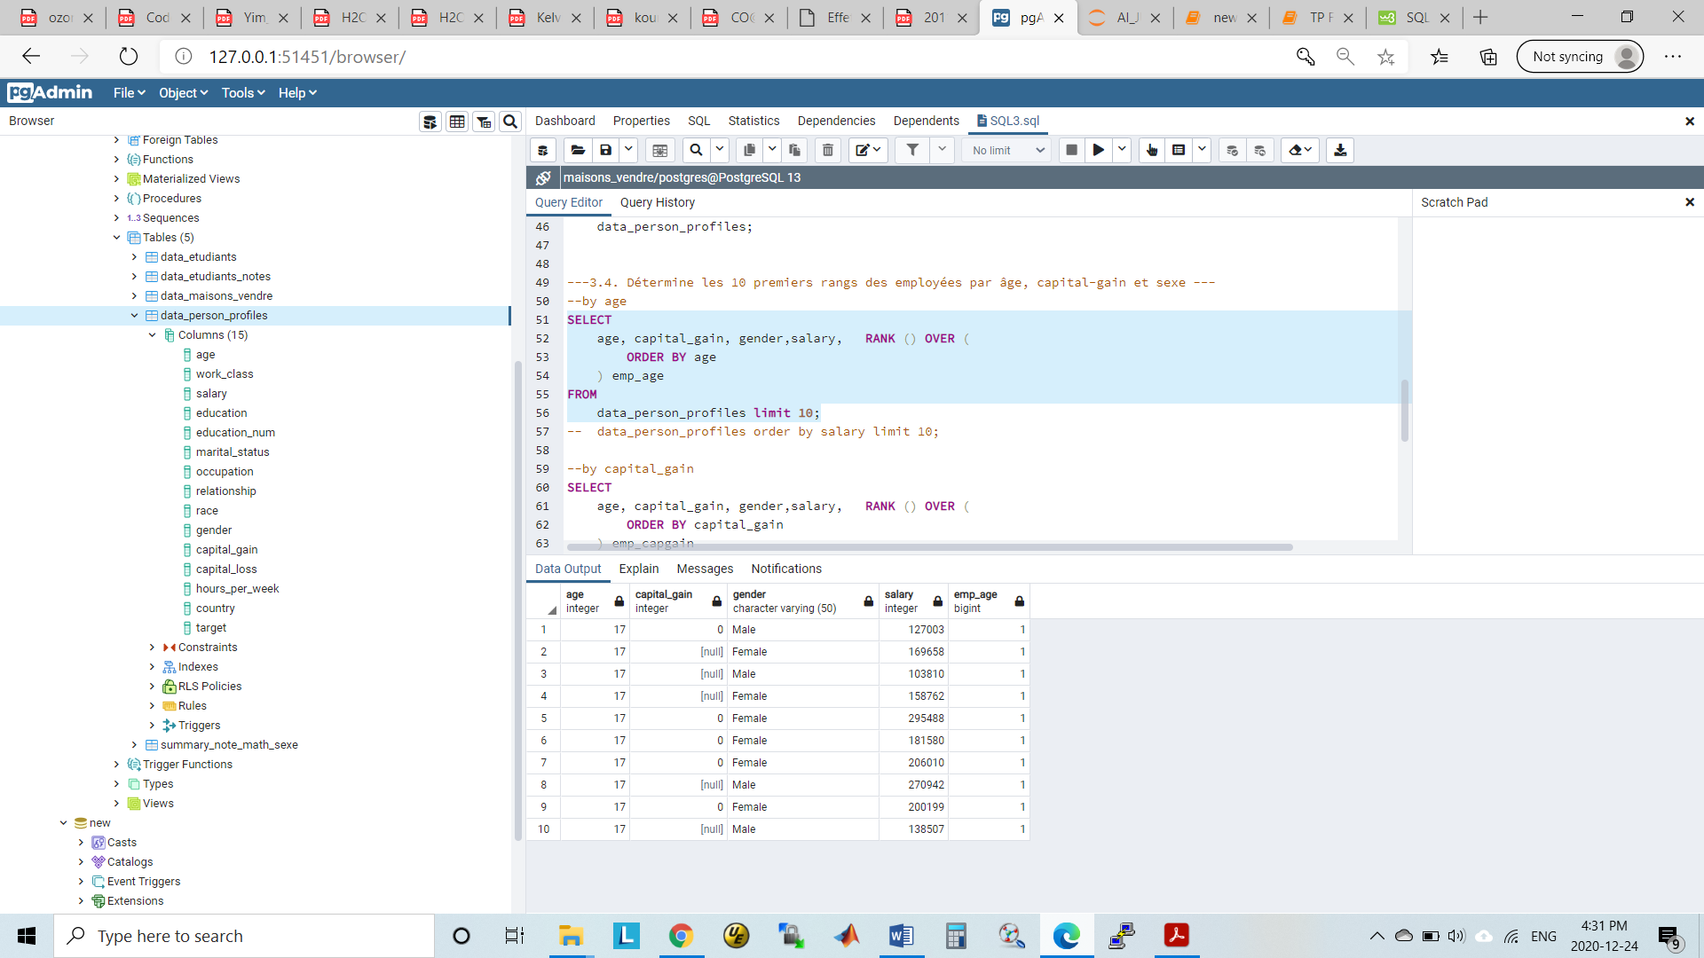

--by capital_gain

SELECT

age, capital_gain, gender,salary, RANK () OVER (

ORDER BY capital_gain

) emp_capgain

FROM

data_person_profiles limit 10;

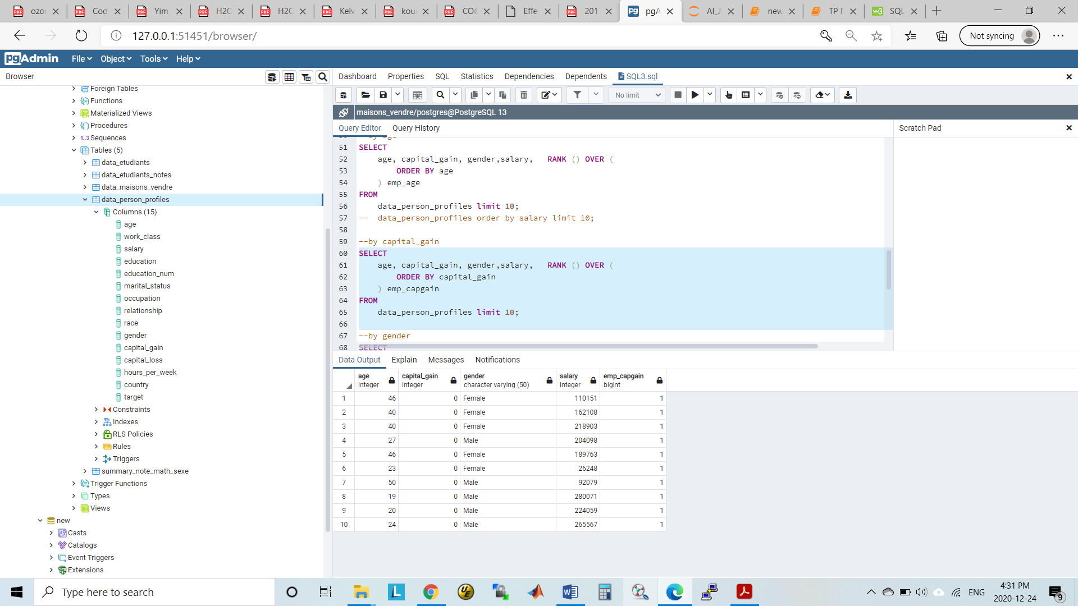

--by gender

SELECT

age, capital_gain, gender, salary, RANK () OVER (

ORDER BY gender

) emp_gender

FROM

data_person_profiles limit 10;

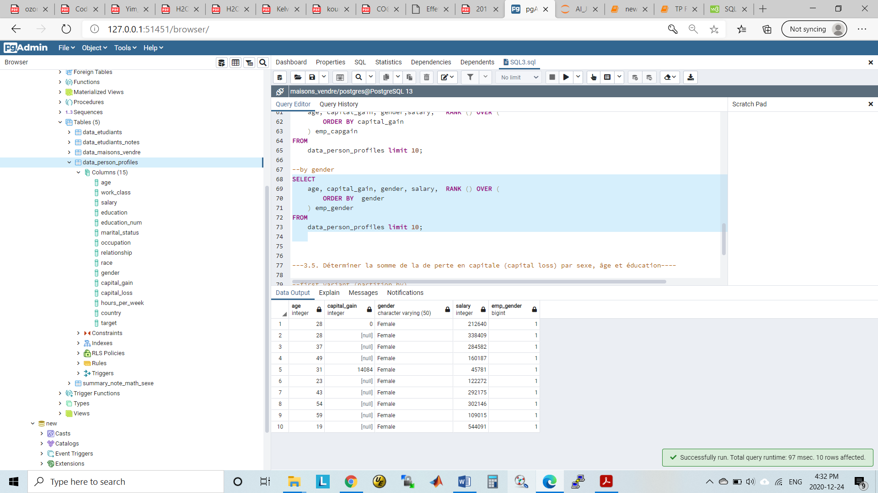

---3.5. Determiner la somme de la de perte en capitale (capital loss) par sexe, Age et Education----

--first variant (partition by)

select distinct gender , sum(capital_loss) over (partition by gender) capital_loss from data_person_profiles ;

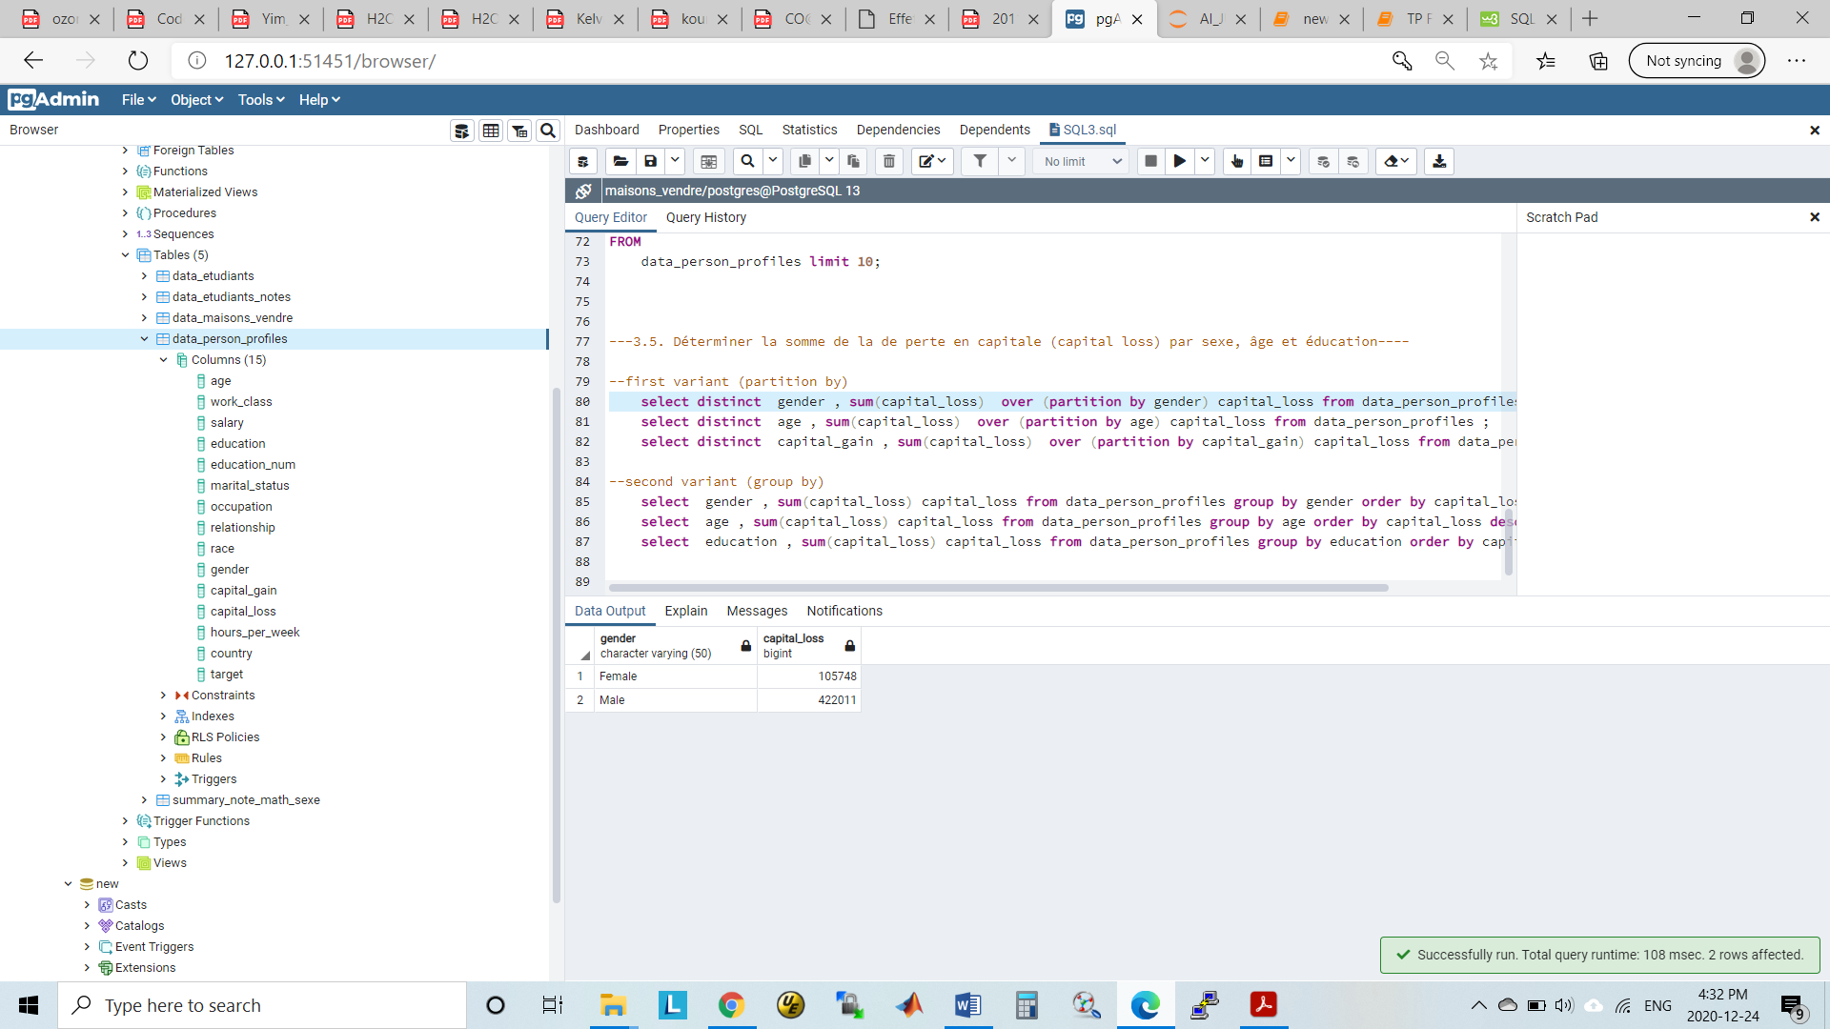

select distinct age , sum(capital_loss) over (partition by age) capital_loss from data_person_profiles ;

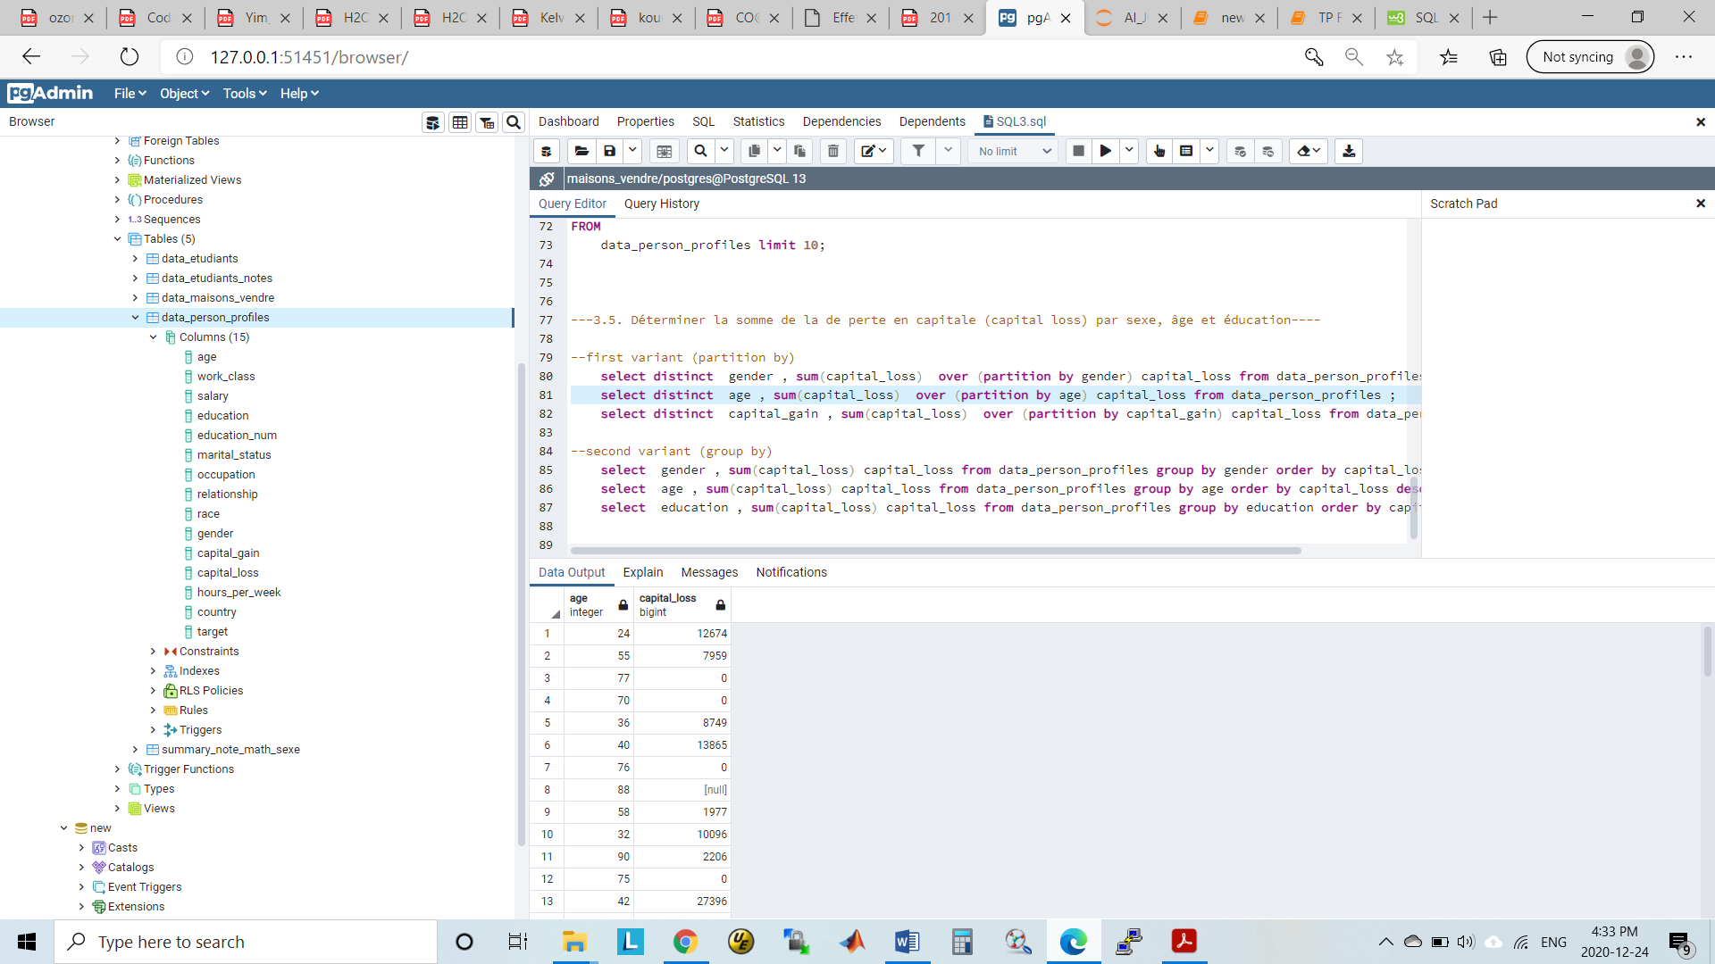

select distinct education , sum(capital_loss) over (partition by education) capital_loss from data_person_profiles ;

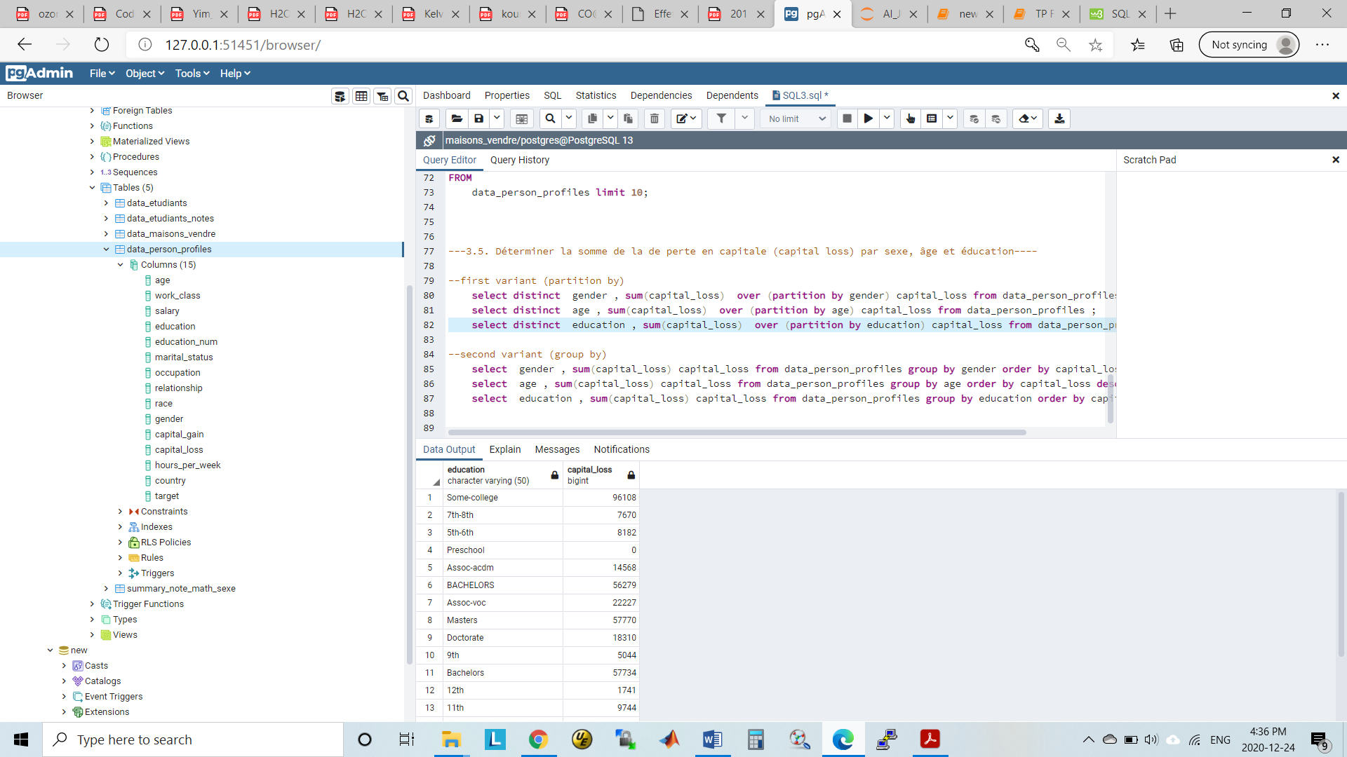

--second variant (group by)

select gender , sum(capital_loss) capital_loss from data_person_profiles group by gender order by capital_loss desc;;

select age , sum(capital_loss) capital_loss from data_person_profiles group by age order by capital_loss desc;;

select education , sum(capital_loss) capital_loss from data_person_profiles group by education order by capital_loss desc;